**Sprint 1 - Endurance Design Document**

**November 16, 2020**

**Table of Contents**

**1.EXECUTIVE SUMMARY3**

1.1Project Overview3

1.2Purpose and Scope of this Specification3

**2.PRODUCT/SERVICE DESCRIPTION3**

2.1Product Context3

2.2User Characteristics3

2.3Assumptions3

2.4Constraints3

2.5Dependencies4

**3.REQUIREMENTS4**

3.1Functional Requirements5

3.2Security5

*3.2.1Protection5*

*3.2.2Authorization and Authentication6*

3.3Portability6

**4.REQUIREMENTS CONFIRMATION/STAKEHOLDER SIGN-OFF6**

**5.SYSTEM DESIGN6**

5.1Algorithm6

5.2System Flow6

5.3Software6

5.4Hardware6

5.5Test Plan7

5.6Task List/Gantt Chart7

5.7Staffing Plan7

1. Page Break
2. Executive Summary
3. ***Project Overview***

The purpose of this project is to move a robot and make it stop at certain parts of the room. The target audience is beginners in learning about technology. Since the program is ebay to read a change the functions to users personal reasons. The user has complete control over the robot and what it will do and how it will do it.

1. ***Purpose and Scope of this Specification***

Describe the purpose of this specification and its intended audience. Include a description of what is within the scope and what is outside of the scope of these specifications. For example:

**In scope**

This document addresses requirements related to phase 2 of Project A:

* The intended audience is Monmouth students in the computer science department.
* The robot must complete a specific course in a specific manner.

**Out of Scope**

The following items in phase 3 of Project A are out of scope:

* Robot completing the second course

1. Product/Service Description

In this section, describe the general factors that affect the product and its requirements. This section should contain background information, not state specific requirements (provide the reasons why certain specific requirements are later specified).

1. ***Product Context***

How does this product relate to other products? Is it independent and self-contained? Does it interface with a variety of related systems? Describe these relationships or use a diagram to show the major components of the larger system, interconnections, and external interfaces.

1. ***User Characteristics***

* Student in the computer majors
* People learning about block coding.
* technical expertise could beginning
* Must know little about the programing

1. ***Assumptions***

* The Operation system is free and easy to download on any device.
* The equipment is available at many retail stores
* If the operating system is not able to download then the robot will not work.
* The expertise required is very little for the reason that the Operating system is very user friendly.

1. ***Constraints***

Describe any items that will constrain the design options, including

* Room wasn't available during group meeting
* Floor was not leveled
* Space wasn't big enough for the provided measurements. Halved all measurements
* Group could not meet because of work.

1. ***Dependencies***

* The space that is available during the testing of the robot
* The aim of the robot will change each time after it disconnects from the device and needs to be reset.

.

1. Requirements   
   ***Functional Requirements***

|  |  |  |  |  |  |
| --- | --- | --- | --- | --- | --- |
| **Req#** | **Requirement** | **Comments** | **Priority** | **Date Rvwd** | **SME Reviewed / Approved** |
| ENDUR_01 | Led light needs to be green | Led must be maintained until last stopping point | third | 11/16 | Devin |
| ENDUR_02 | Needs to say “ready set go” | Voice needs to clear and audible | second | 11/16 | Devin |
| ENDUR_03 | Needs to go around the room stopping at certain points | The robot must go around a make stops a certain point around the course | first | 11/16 | Devin |
| ENDUR_04 | Led light needs to be red | Led must change into the different color when needed | fourth | 11/16 | Devin |
| ENDUR_05R | Needs to say “Im done I need water | The voice must be clear and the robot must speak it at the right time. | fifth | 11/16 | Devin |

1. ***Security***
2. **Protection**

* encryption
* activity logging, historical data sets
* restrictions on intermodule communications
* data integrity checks
* Password protected to edit the program on the device that the program was created on.

1. **Authorization and Authentication**

Specify the Authorization and Authentication factors. Consider using standard tools such as PubCookie.

1. ***Portability***

If portability is a requirement, specify attributes of the system that relate to the ease of porting the system to other host machines and/or operating systems. For example,

* Percentage of components with host-dependent code; the robot is 100% dependent on the code
* Percentage of code that is host dependent; 100%
* Block coding can sent file on any platform
* Sphero app that any device can run.
* The need for environment-independence - the product must operate the same regardless of operating systems, networks, development or production environments.

1. Requirements Confirmation/Stakeholder sign-off

Include documentation of the approval or confirmation of the requirements here. For example:

|  |  |  |
| --- | --- | --- |
| **Meeting Date** | **Attendees (name and role)** | **Comments** |
| 110/29/2020 | Jack Berkowitz John Cheema, Devin Brattvet | confirmed all |
| MM/DD/YY | My group member names | confirmed…………. |

1. System Design

This section will provide all details concerning the technical design, staffing, coding, and testing the system

1. ***Algorithm***

speak(“Ready Set Go”)

greenLight = True

WHILE (robot not reached yellowTile)

Travel 22’

Turn 90º right

WHILE(robot not reached secondYellowTile)

Travel 11’ 8”

Turn 90º right

WHILE(robot not reached thirdYellowTile)

Travel 21’ 6”

Turn 90º right

WHILE(robot not reached yellowTile)

Travel 11’ 9”

greenLight = False

redLight = True

speak(“I’m done and I need water!”)

1. ***System Flow***
2. ***Software***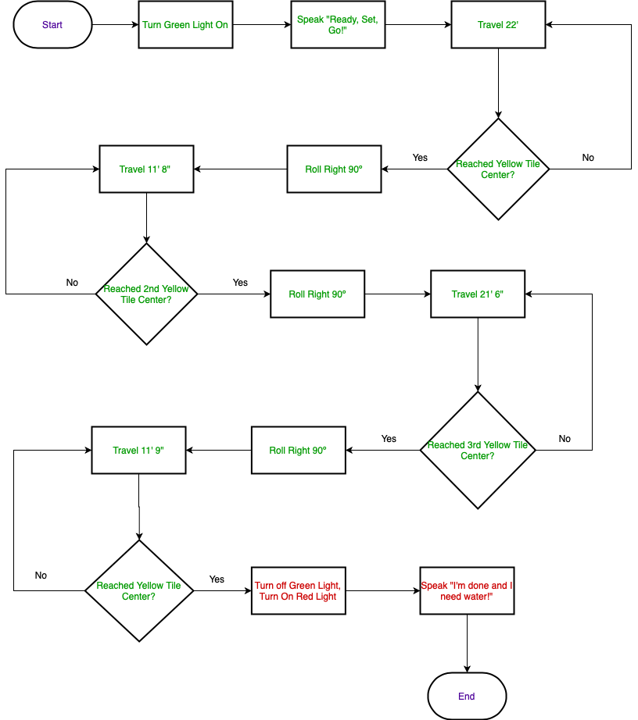

The software used to program this application is called Sphero Edu. We used block coding to program the robot.

1. ***Hardware***

The hardware used is Sphero Edu SPRK+ STEM Robot to develop and test the code.

1. ***Test Plan***

|  |  |  |  |  |  |
| --- | --- | --- | --- | --- | --- |
| **Reason for Test Case** | **Test Date** | **Expected Output** | **Observed Output** | **Staff Name** | **Pass/Fail** |
| To see if the robot reaches the first stop on the floor | 10/31/.2020 | Robot will roll the wrong way but with enough time to halfway reach the destination. | Robot crashed into a wall with force. | Jack | fail |
| To see if the robot can reach the by the first stop | 10/31/2020 | Robot will roll the right way but wont reach | Robot almost reach goal but requires more time to make the first stop. | Jack | fail |
| To see if the robot can reach the by the first stop | 10/31 | More time was added. The robot either will overshoot the first stop or stop in time. | The robot overshoot the stop and angled over course. | jack | fail |
| To see if the robot can reach the by the first stop | 10/31 | The angle of the robot was changed and time was reduced. I think it should make the stop and stay in a straight line. | The robot stayed in a stright line but it over shot the stop point. |  | fail |
| To see if the robot can make it to the first stop point and stay on a straight course. | 10/31 | I reduced the time and changed the angle. It should stop at the point perfectly. | The robot stayed on course, but over shot the stop point by half an inch. | jack | fail |
| To see if the robot can make it to tbhbe first stop point and stay straight on course | 10/31 | The angle was reduced and time changed. I think it will pass the test. | The robot stayed straight and stopped at the right time. | jack | pass |
| Test the first part of the program | 11/1 | The program will pass | For some reason the robot won't stop or turn straight as it did before | jack | fail |
| To see if the angles i changed it to and changed the aim of the robot affect the outcome | 11/1 | The robot will stop short or to far | The robot stopped in time and remained straight | jack | pass |
| To see fi the robot can stop and then make a turn | 11/1 | The robot will stop and make the turn but will not make it to the second point | The robot stopped but overshot the stopping point | jack | fail |
| To see if the robot can travel top the first stop point than make a right turn to the second point | 11/5 | The robot will make the stop and the turn but will not stop in time | The robot made the stop and stopped at the right point | jack | pass |
| To see if the robot can run the course and stop at the second to last stopping point  To see if the robot can finish the course  To see if the robot lights, speaks, and runs the course all | 11/5  11/5 | The robot will make the first two stopping points than will not go on a straight course for the third point  The robot will finish the course and land on the stopping points  . | The robot made all stopping points and went straight for the third point  The robot landed on all stopping points and completed the course | Jack  Jack | Pass  pass |

1. ***Task List/Gantt Chart***

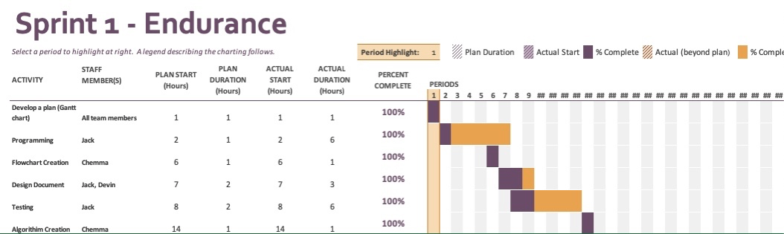

1. ***Staffing Plan***

|  |  |  |  |
| --- | --- | --- | --- |
| Name | Role | Responsibility | Reports To |
| Jack Berkowitz | Programer and tester for the robot | To maintain the programs,tests, | John |
| John Cheema | Data Recorder | Writes all data recorders into the document. | Devin |
| Devin Brattvet | Project Manager | Gantt chart functional requirements. | Devin |